A REPORT
ON
EXTENSION ACTIVITIES
NAGAON GNDG COMMERCE COLLEGE
PERIOD:2021 – 2022

1.NAME OF ACTIVITY: Paediatric Cancer Awareness Programme
2. VENUE :Palashani LP School, Village Palashani
3.DATE : 3rd March ,2022
4.A BRIEF REPORT The department of English and Department of Statistics jointly organized an awareness programme on childhood cancer in collaboration with Lions’ Club of Nagaon on 3rd March 2022 at PalashanivillageThe village is an adopted village of the institution and we attempt to undertake beneficial projects for the villagers living there.Dr Akashi Hazarika, a renowned paeditrician from Nagaon addressed the gathering and sensitized them about various important facts related to this disease. A large number of residents of the area ,mostly women attended the programe and many of them had their doubts and concerns addressed by the physician.
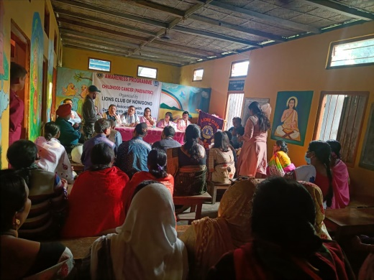
5.Number of VOLUNTEERS PRESENT 12
6.TEACHERS PRESENT 10
7.NUMBE OF BENEFICIARIES 30.
PHOTOGRAPHS
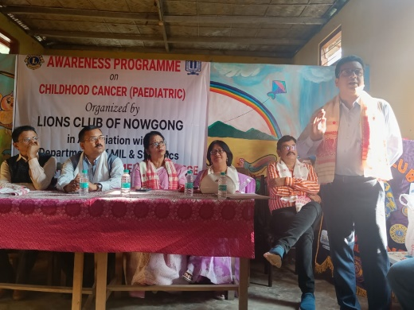
MEDIA COVERAGE

