A REPORT
ON
EXTENSION ACTIVITIES
NAGAON GNDG COMMERCE COLLEGE
PERIOD:2021 – 2022

1.NAME OF ACTIVITY Women’s Day Celebration
2. VENUE : Village Karaiyani
3.DATE : 8thMarch ,2022
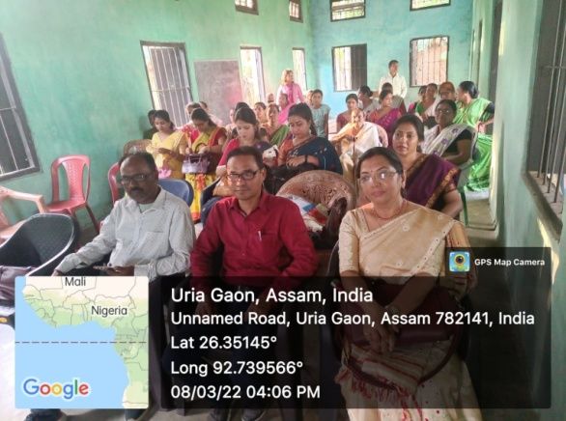
4.A BRIEF REPORT The Women”s Cell of Nagaon GnDG Commerce College arranged the celebration of International Women’S Day at village Palaxani.DrArunthatiDevChoudhuri A government officer from the department of agriculture attended the programme as resource person. DrChoudhury had a very animated discussion with the women folk present regarding different issueds pertaining to the role of women in a rural economy and the important part played by a women in agricultural activities that help to sustain the society. A large number of teachers were also present on the occasion. Earlier in the day a drawing competition was organized among the children of the area. Later there was a cultural performance by the members of AangavinoyAxom and from amongst the children present there.
5.Number of VOLUNTEERS PRESENT 15
6.TEACHERS PRESENT 10
7.NUMBER OF BENEFICIARIES 30.
PHOTOGRAPHS
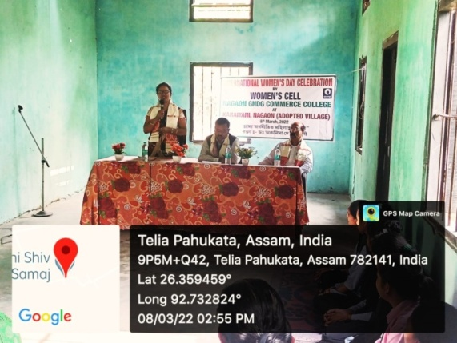
MEDIA COVERAGE
