A REPORT
ON
EXTENSION ACTIVITIES
NAGAON GNDG COMMERCE COLLEGE
PERIOD:2021 – 2022

1.NAME OF ACTIVITY Inauguration of Aangavinoy,Axom
2. VENUE : College Auditorium
3. DATE 1st June,2022
4.A BRIEF REPORT AangavinoyAxom, a dance and acting school of Puranigudam, Nagaon opened a branch for the benefit of the people of Nagaon town and for the students of Nagaon GNdG Commerce College at the college complex. The school imparts lesons in Dance music and Abhinoy, to willing and enthusiastic learners from the locality.
5.Number of VOLUNTEERS PRESENT 15.
6.TEACHERS PRESENT 10
7.NUMBE OF BENEFICIARIES .
PHOTOGRAPHS
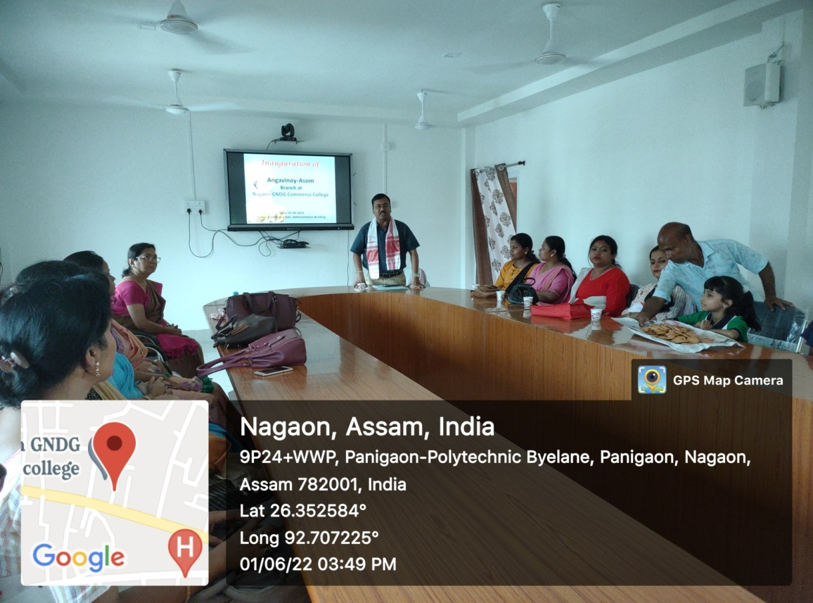
MEDIA COVERAGE

