A REPORT
ON
EXTENSION ACTIVITIES
NAGAON GNDG COMMERCE COLLEGE
PERIOD:2021 – 2022

1.NAME OF ACTIVITY: Eye check up camp
2. VENUE : Village Karaiyani
3.DATE : 29th February 2022
4.A BRIEF REPORT The NSS unit of Nagaon GnDg Commerce College set up an eye check up camp at Karaiani village on 29th February 2022 .DrArindamKhanikar senior opthalmalogist was present on the occasion.The village is an adopted village of the institution and we attempt to undertake beneficial projects for the villagers living there.
5.Number of VOLUNTEERS PRESENT 15
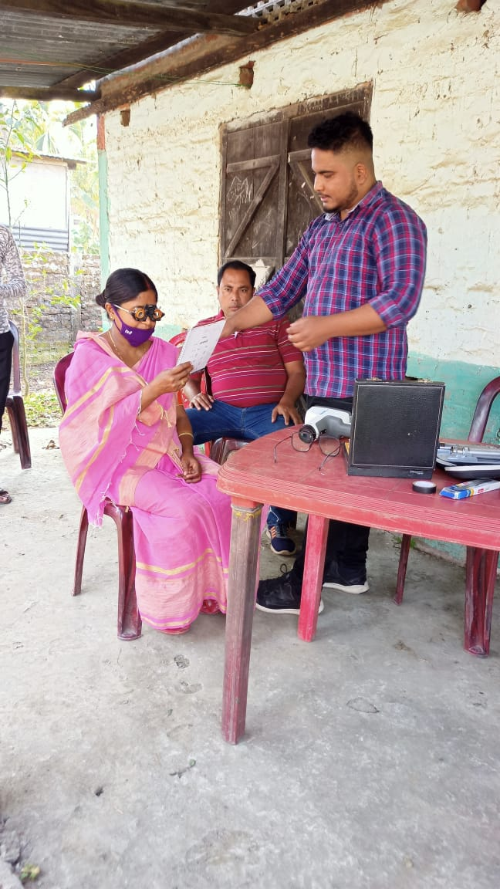
6.TEACHERS PRESENT 4
7.NUMBE OF BENEFICIARIES 49
PHOTOGRAPHS
MEDIA COVERAGE
